MODULE 4: INTRODUCTIONN of dbms
EATRA LAB EXERCISES
1.INTRODUCTION TO SQL:
1.create a new database named school_db and table called students with the following columns: students_id,student_name,age,class and address.
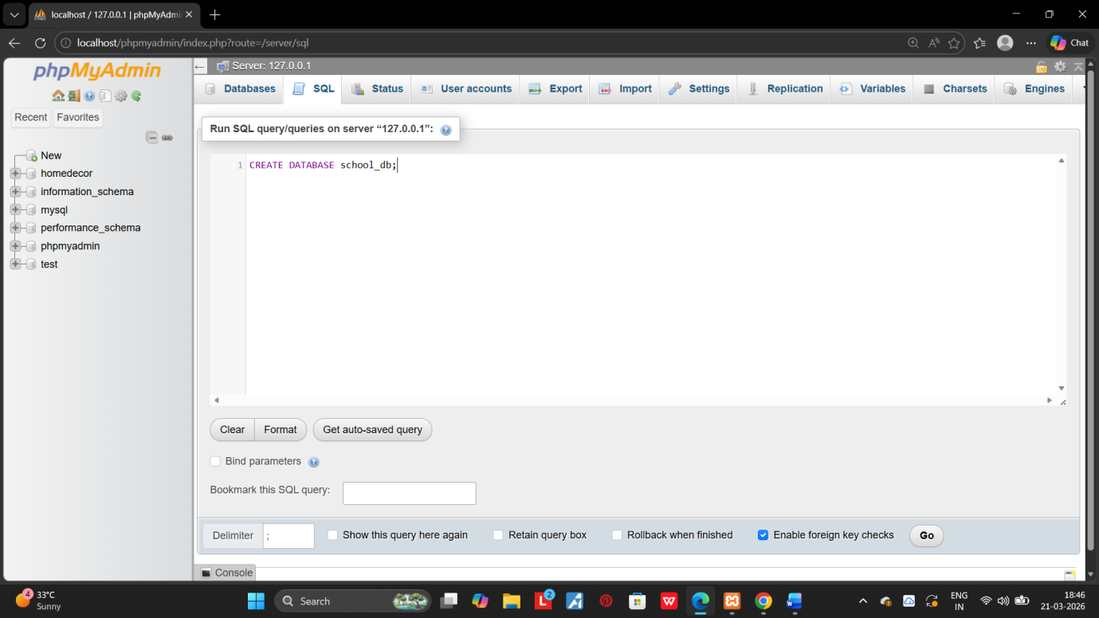
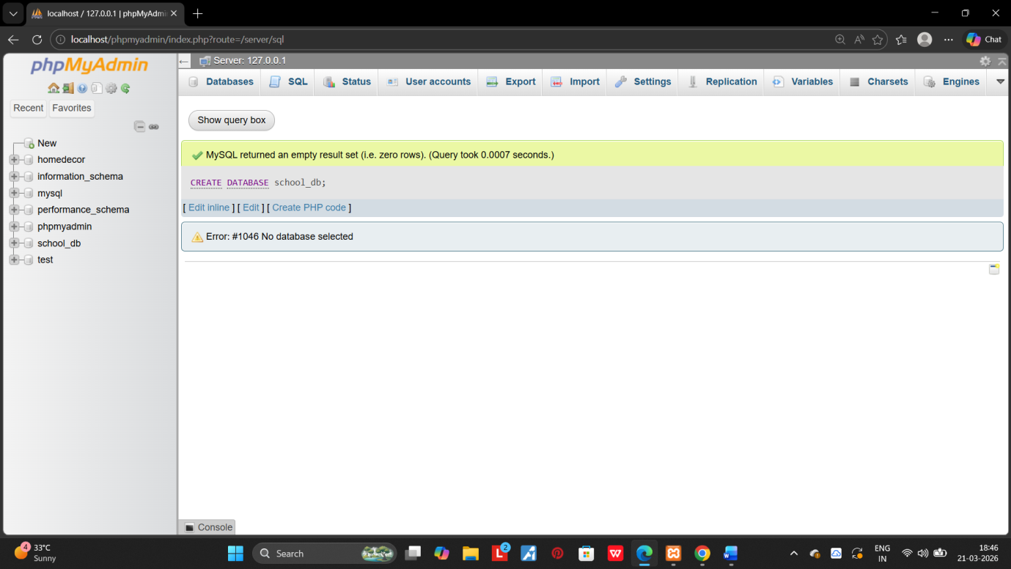
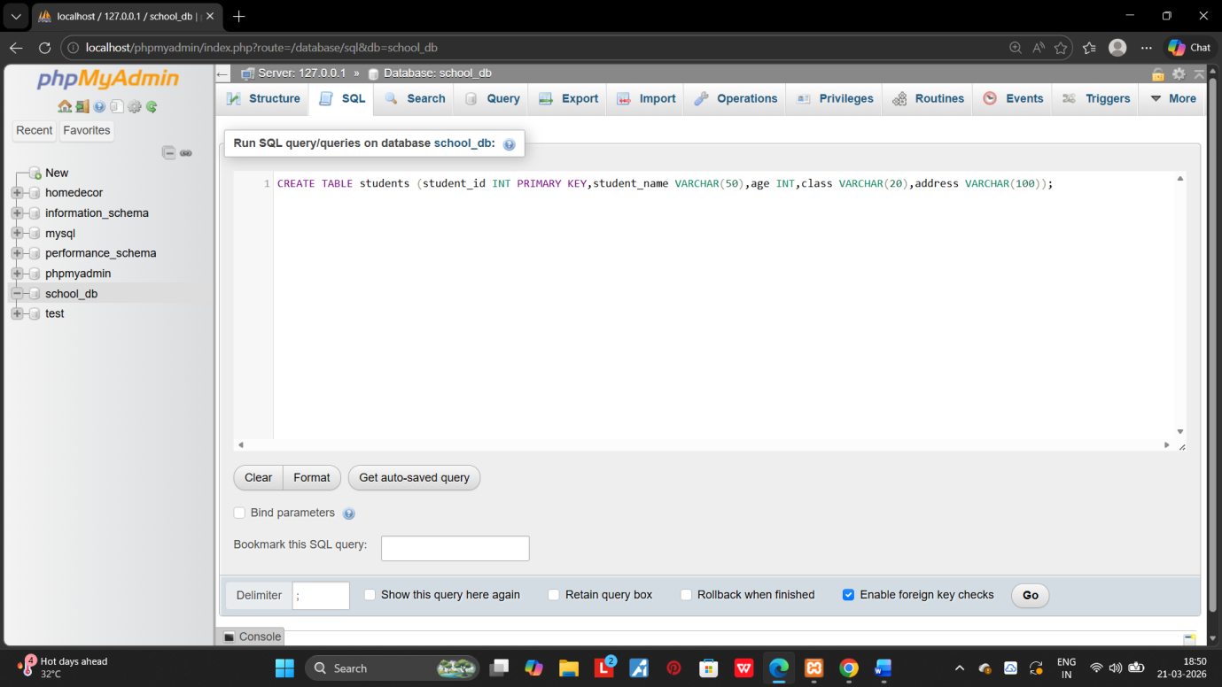
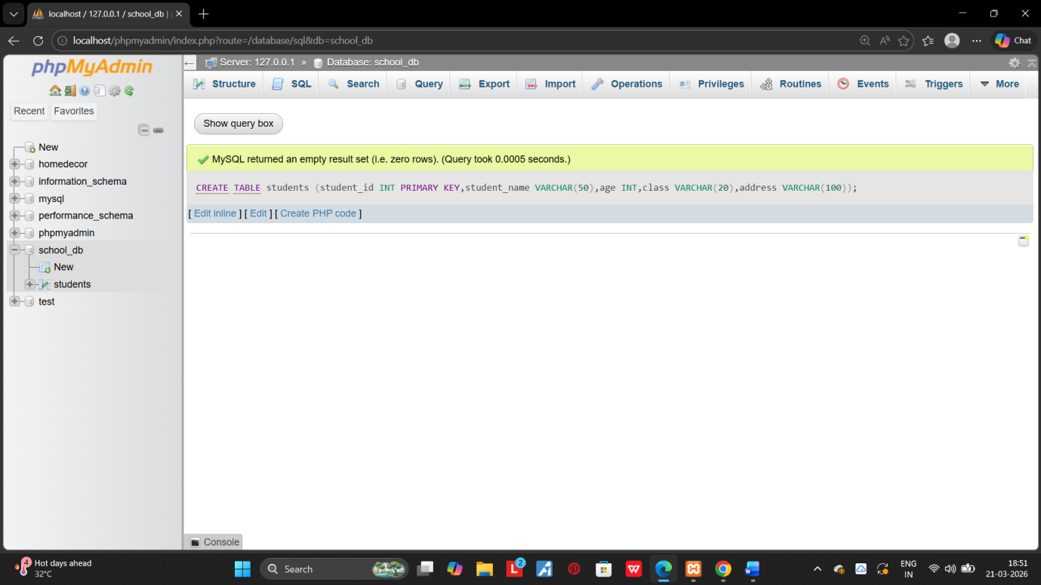
2.Insert five records into the students table and retrieve all records using the SELECT statement.
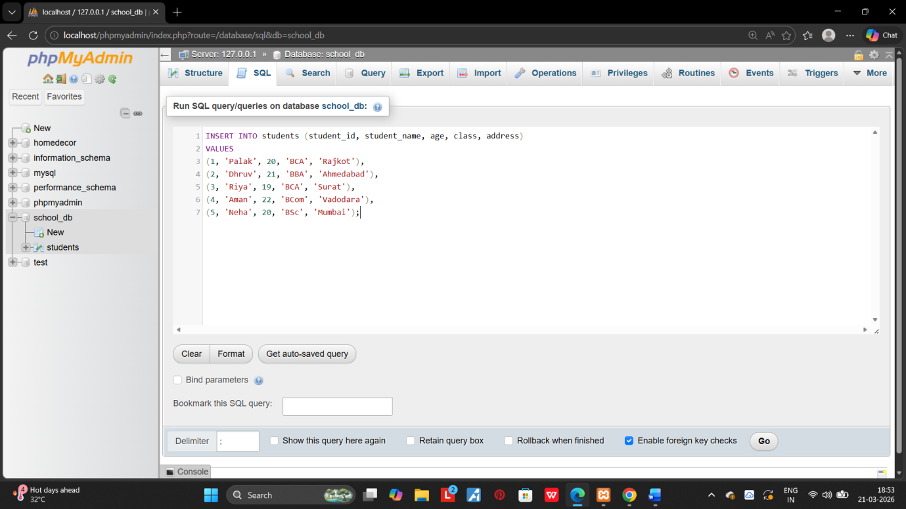
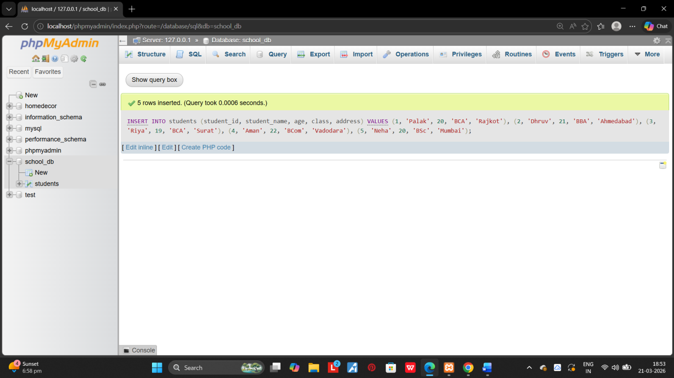
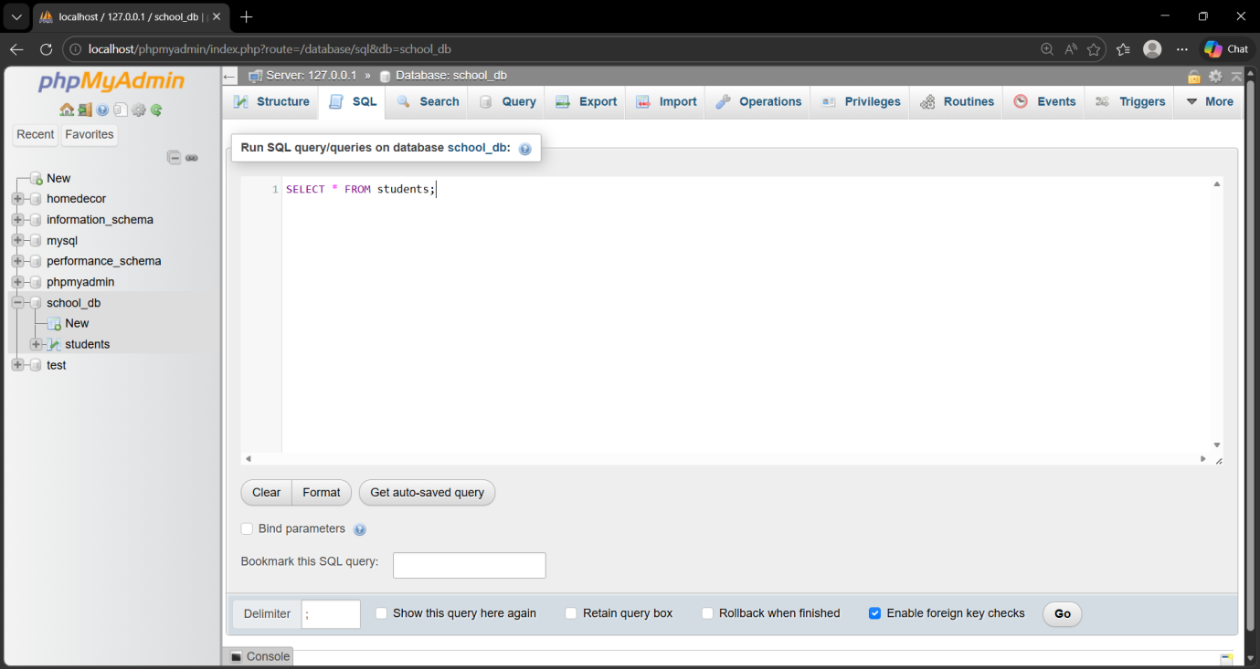
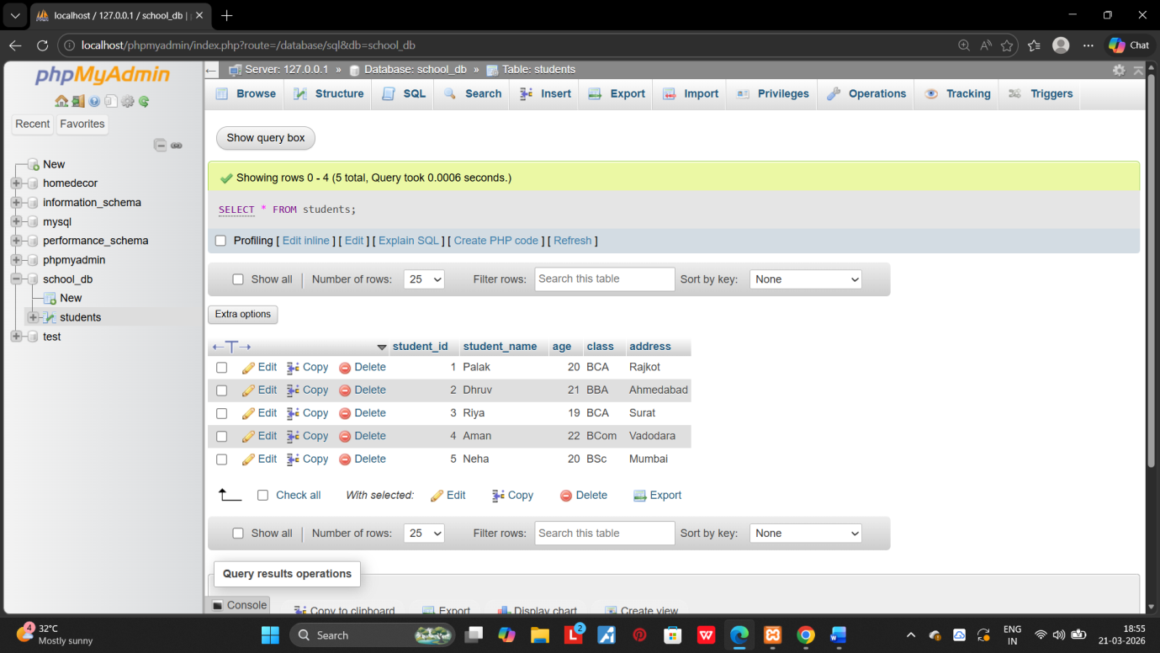

2.SQL SYNTAX:

1.write SQL queries to retrieve specific columns (student_name and age) from the student table.
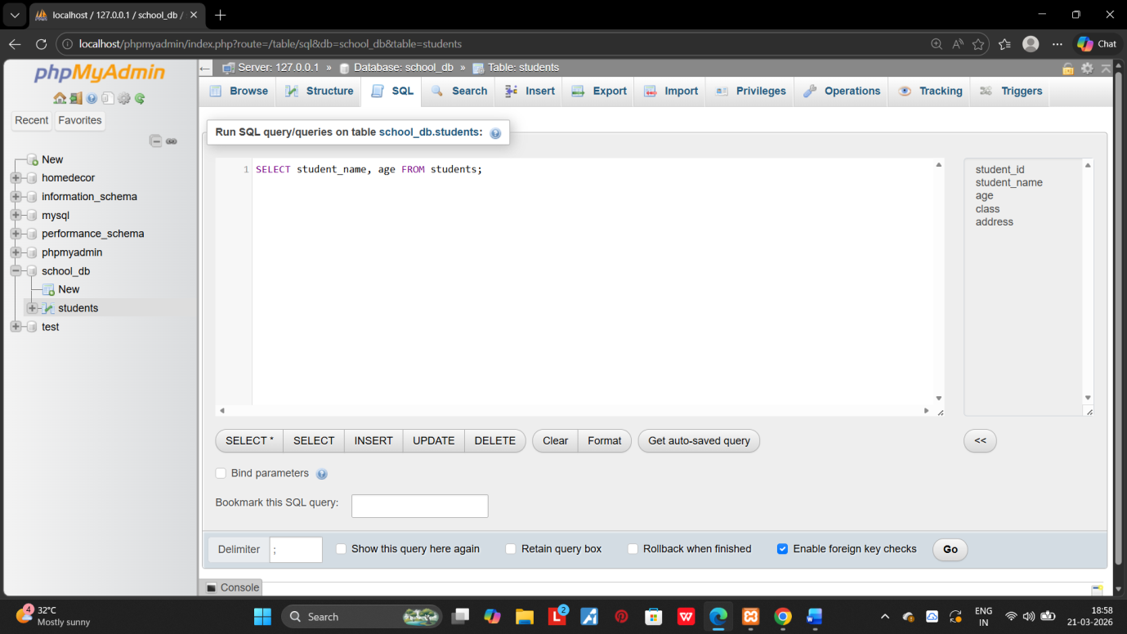
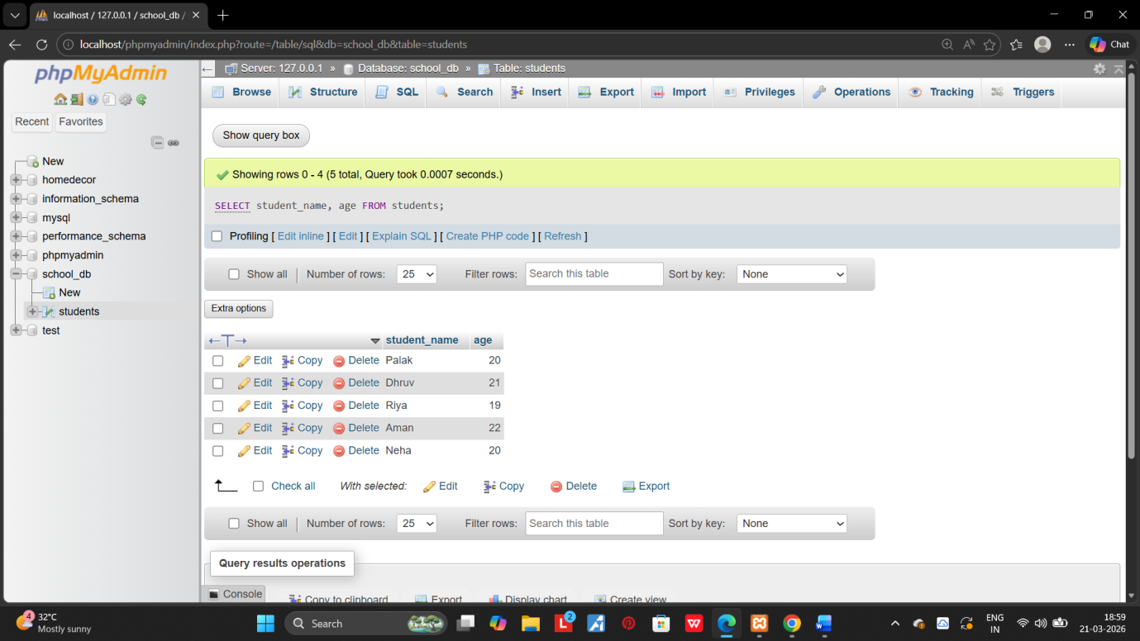
2.Write SQL queries to retrieve all students whose age is greater than 10.
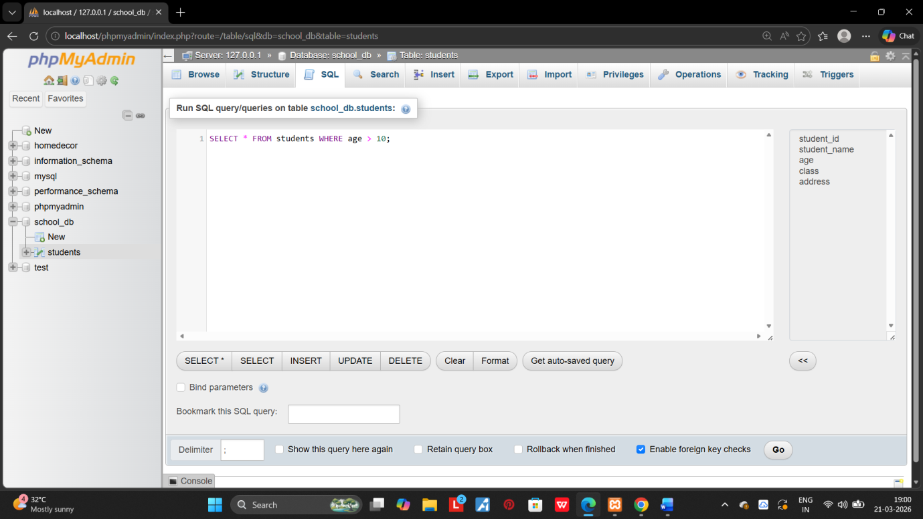
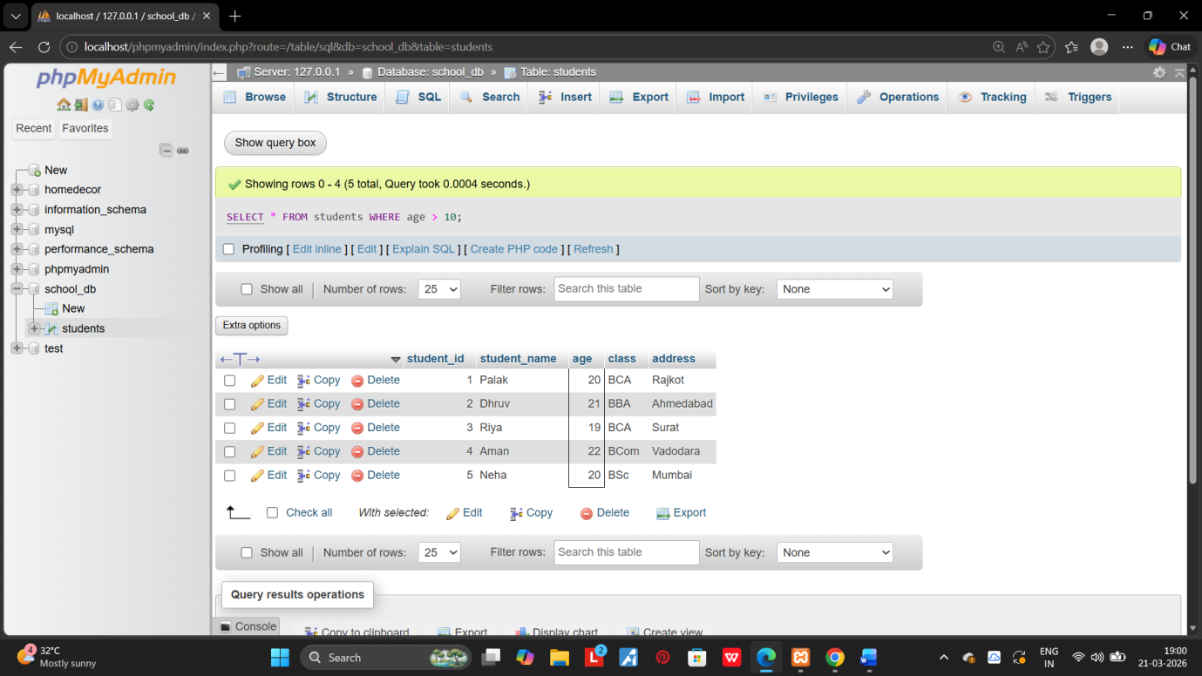

3.SQL CONSTRAINTS:

- create a table teachers with the following columns: teacher_id(primary key), teacher_name(NOT NULL),subject (NOT NULL), and email (UNIQUE).
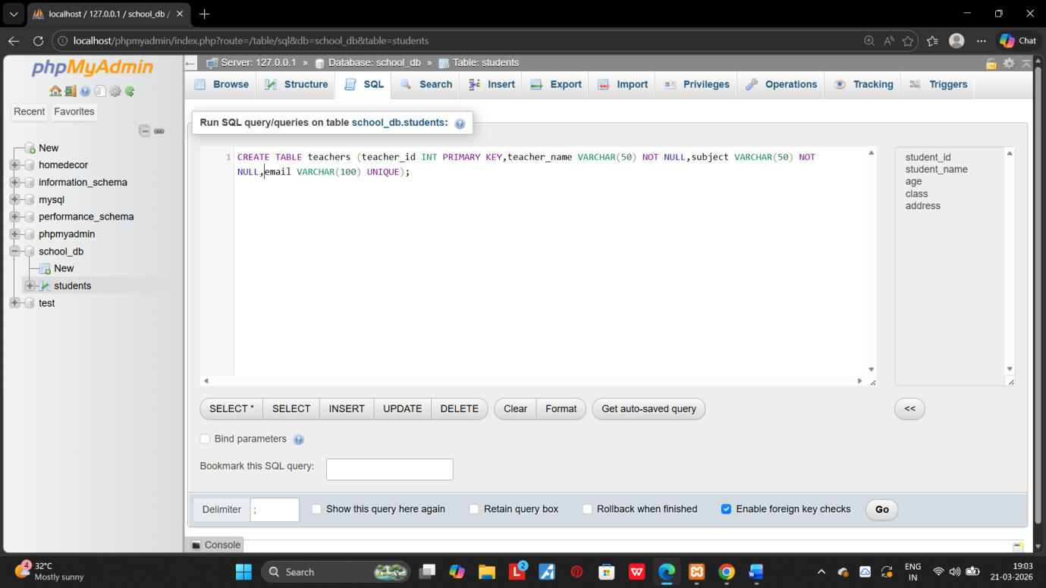
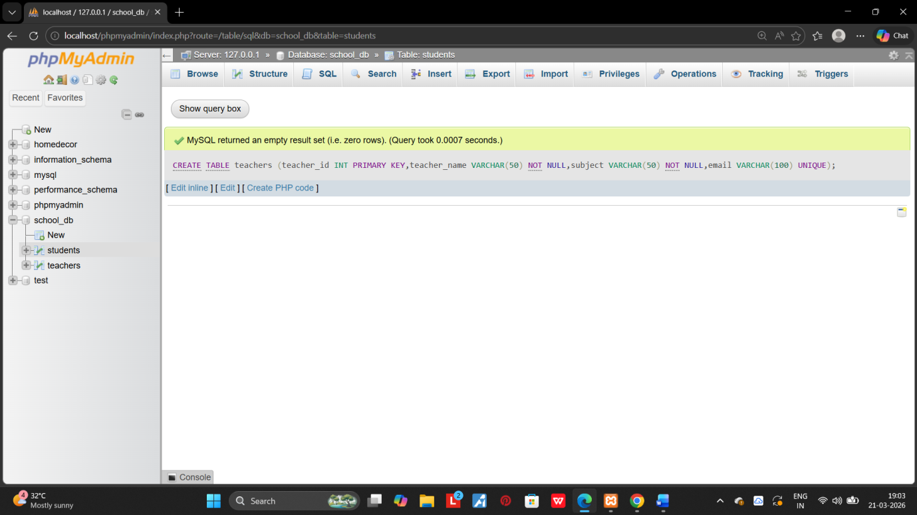
2.Implemnt a FOREIGN KEY constraint to relate the teacher_id from the teachers table with the students table.
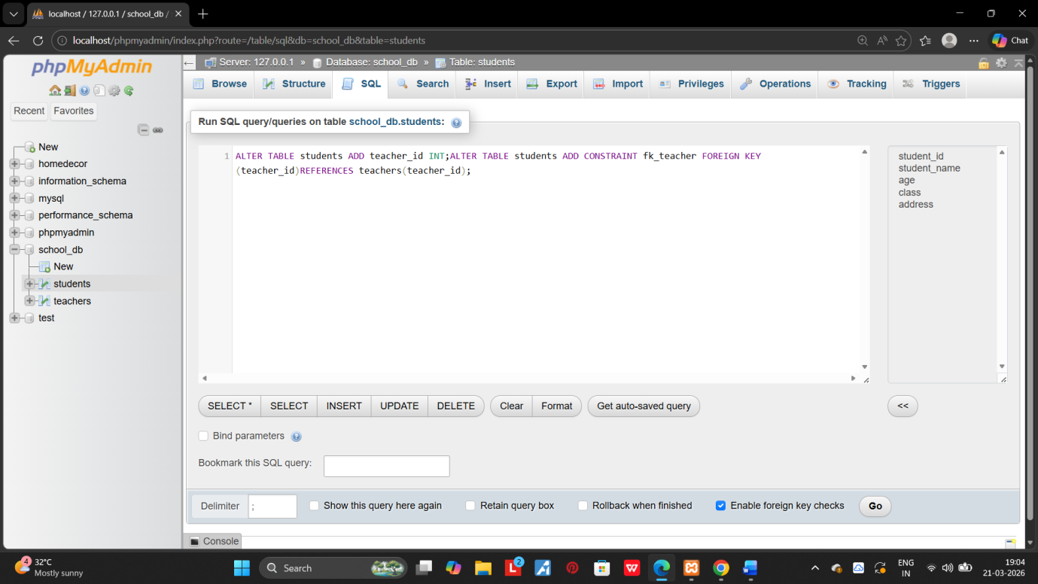
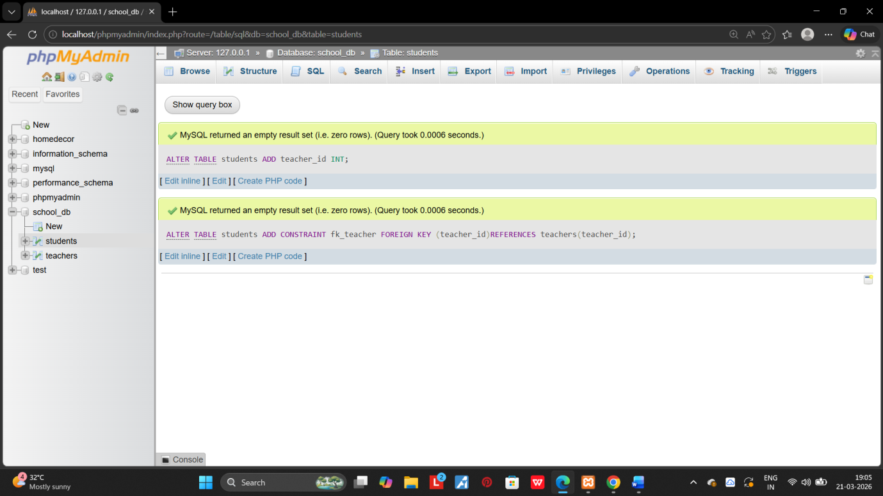

4. MAIN SQL COMMAMNDS AND SUB-COMMANDS (DDL):

1.create a table courses with columns: course_id, course_name, and course_credits. Set the course_id as the primary key.
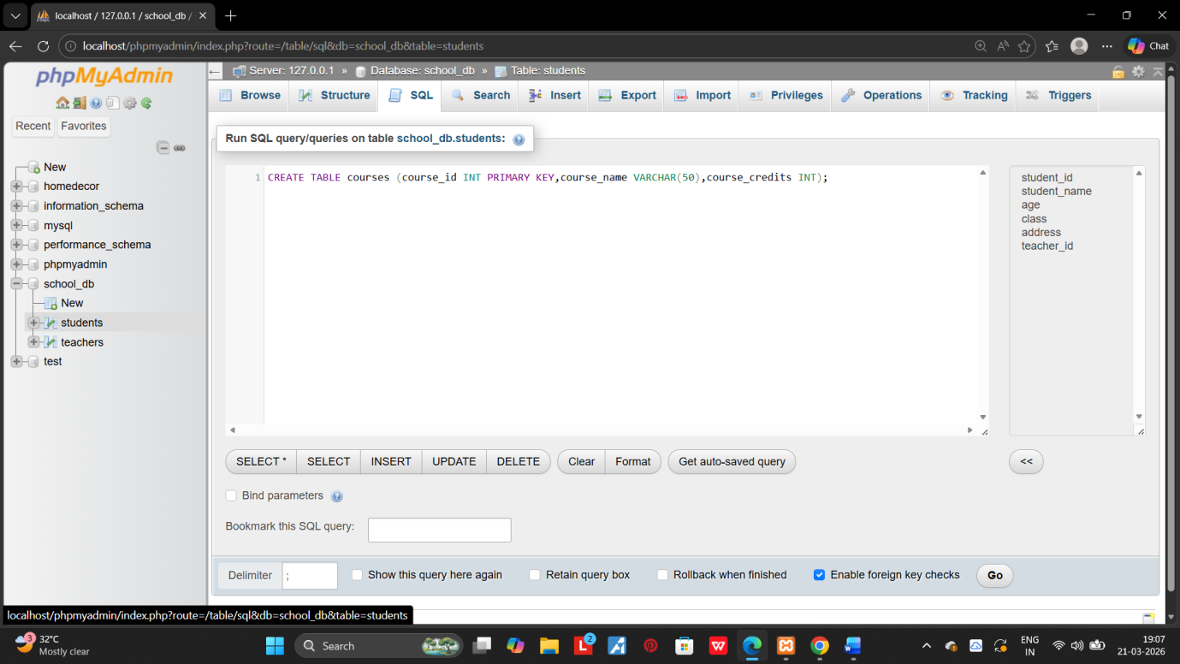
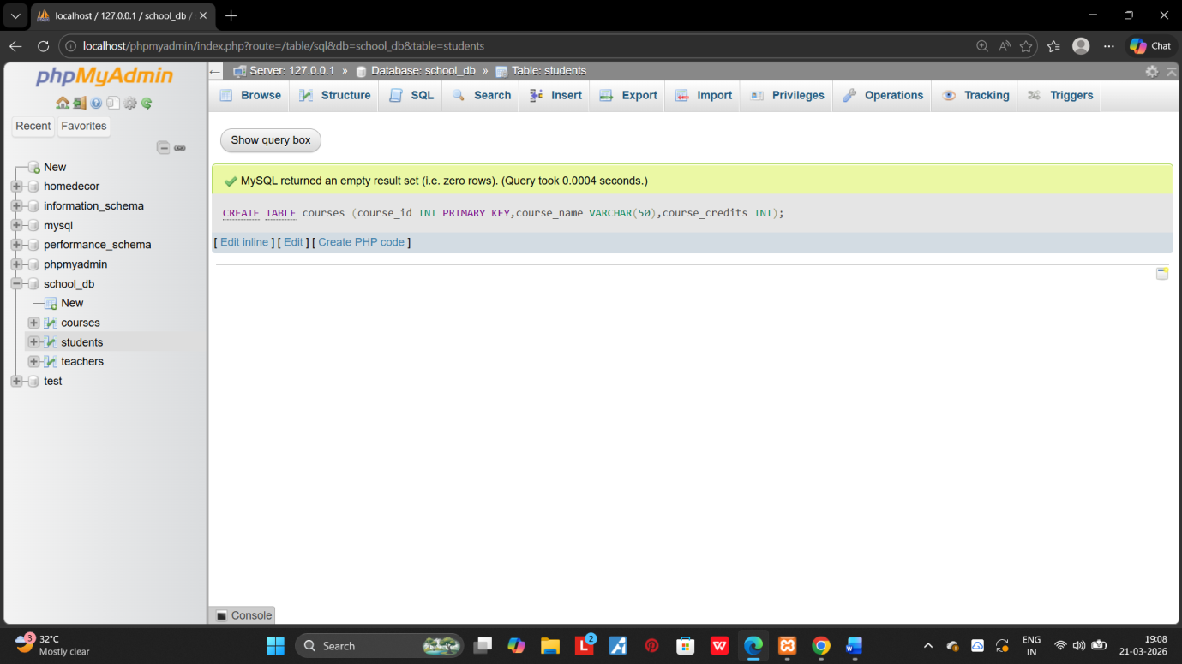

2.use the CREATE command to create a database university_db.
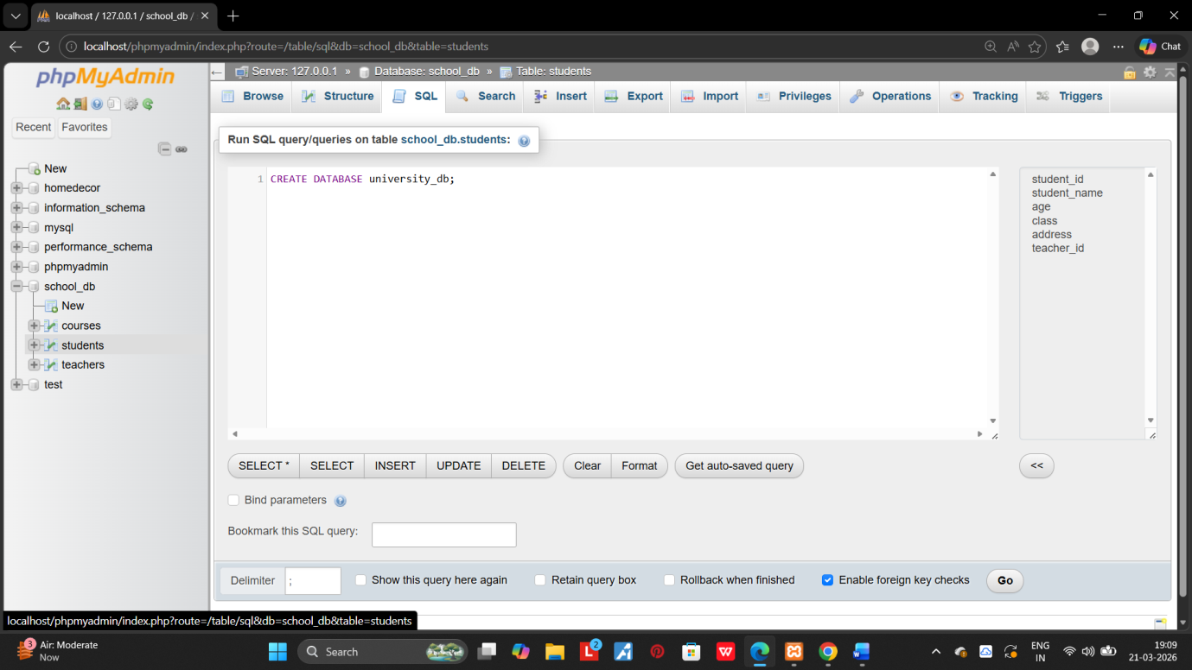
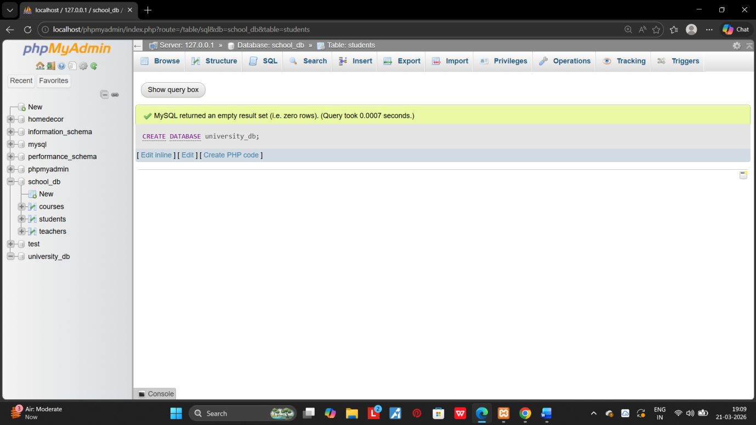

5.ALTER COMMAND:
1.modify the courses table by adding a column course_duration using the ALTER command.
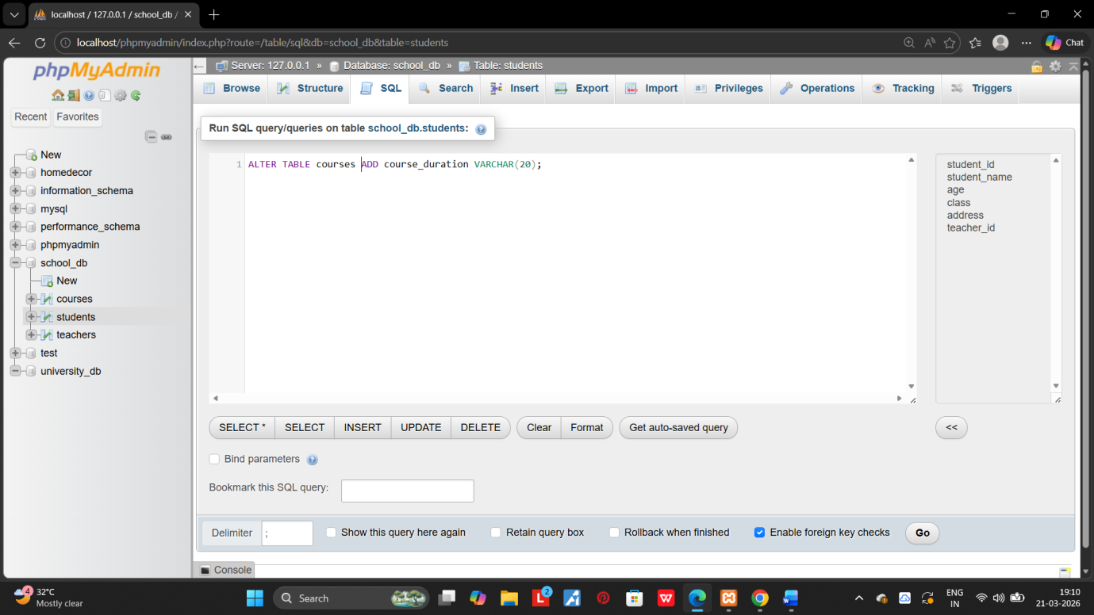
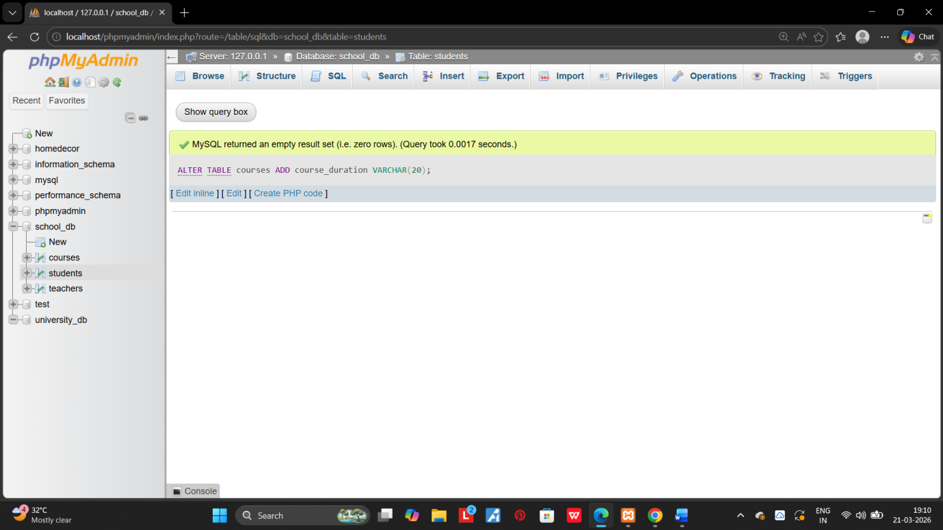
2.Drop the course_credits column from the courses table.
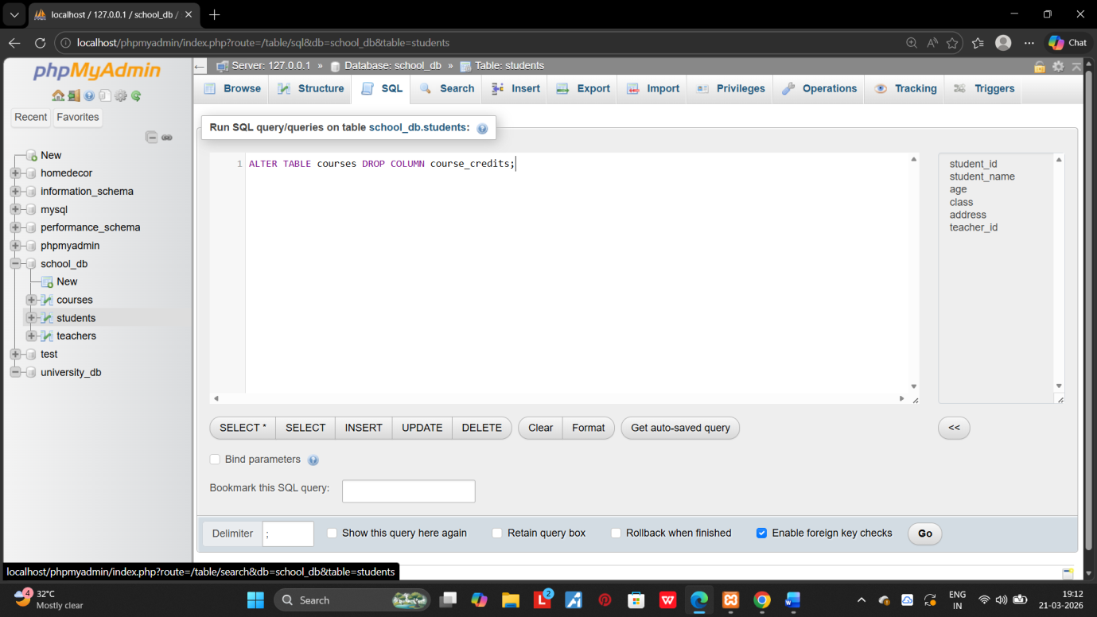
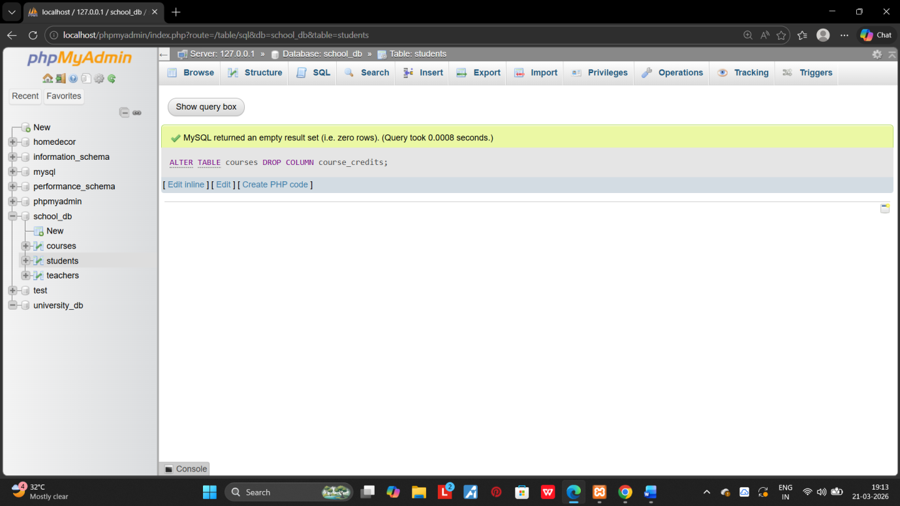

6.DROP COMMAND:

1.Drop the teachers table from the school_db databse.
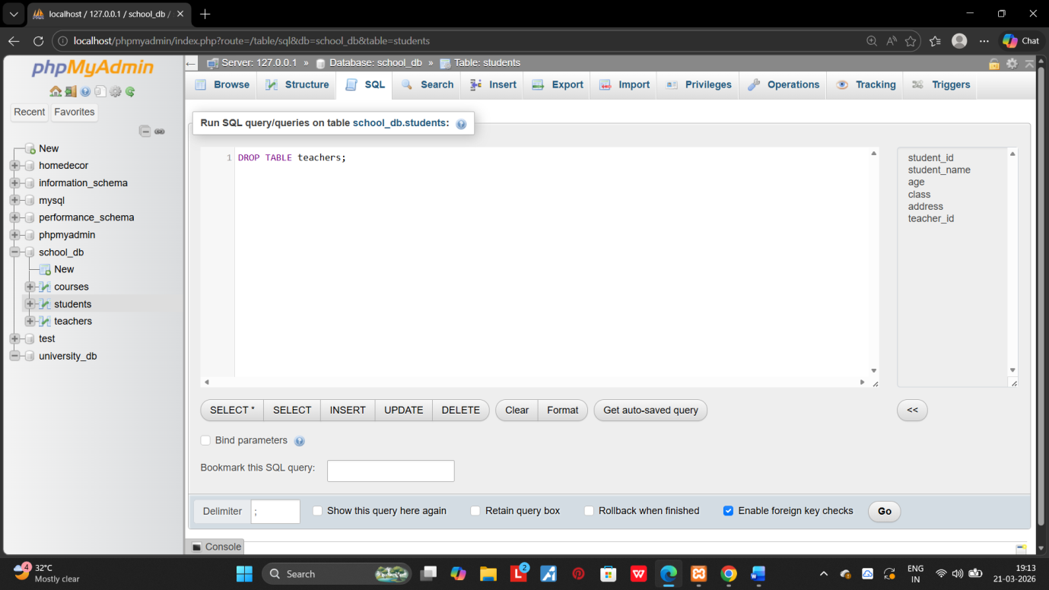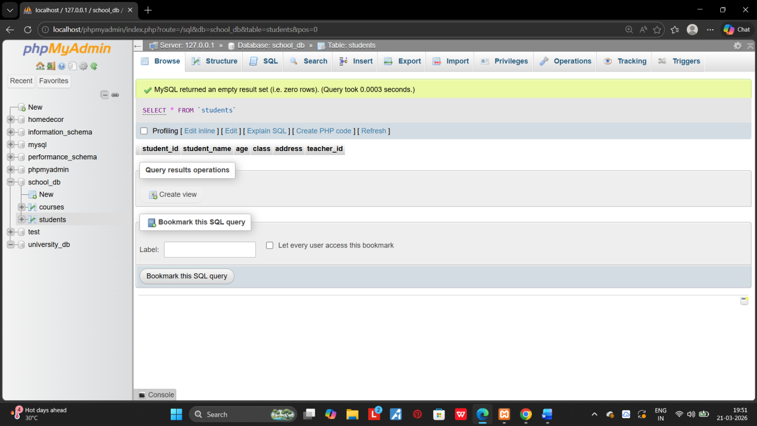

2.Drop the students table from the school_db database and verify that the table has been removed. 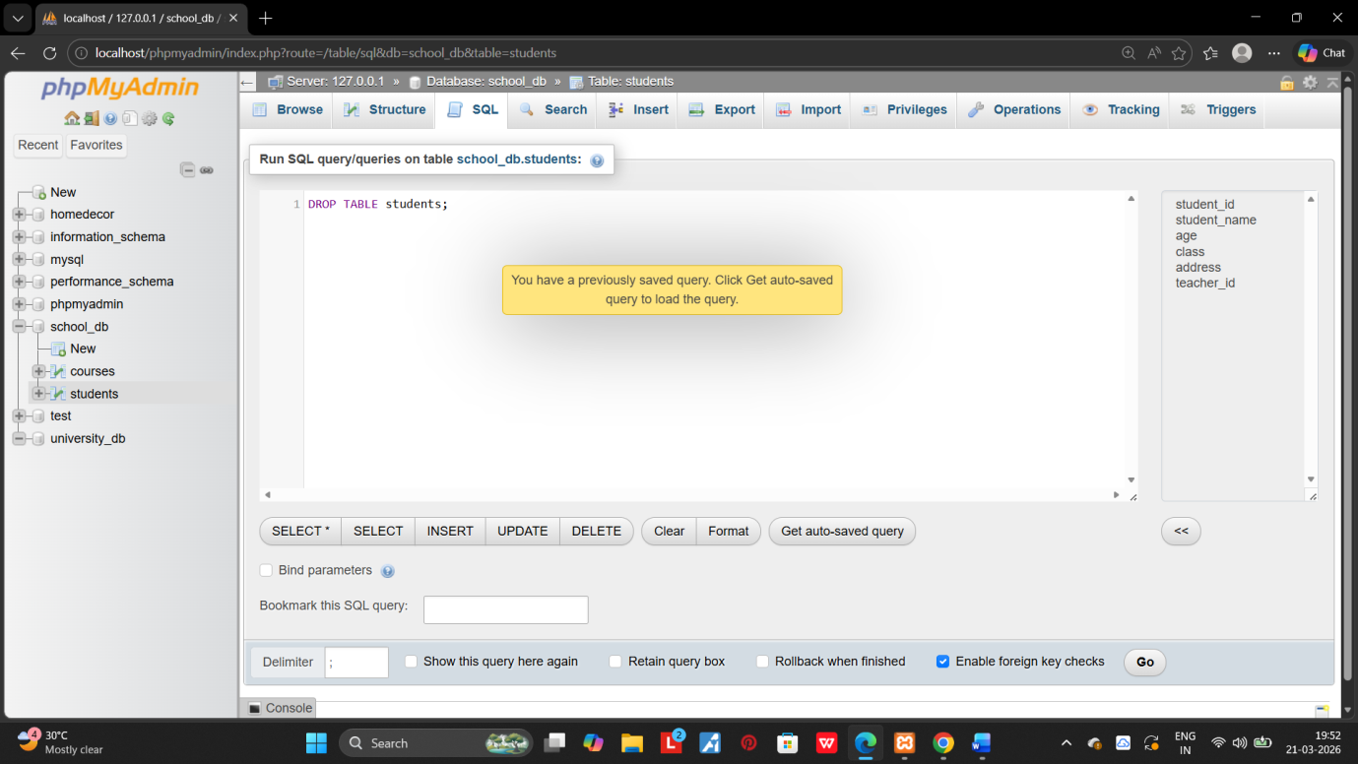

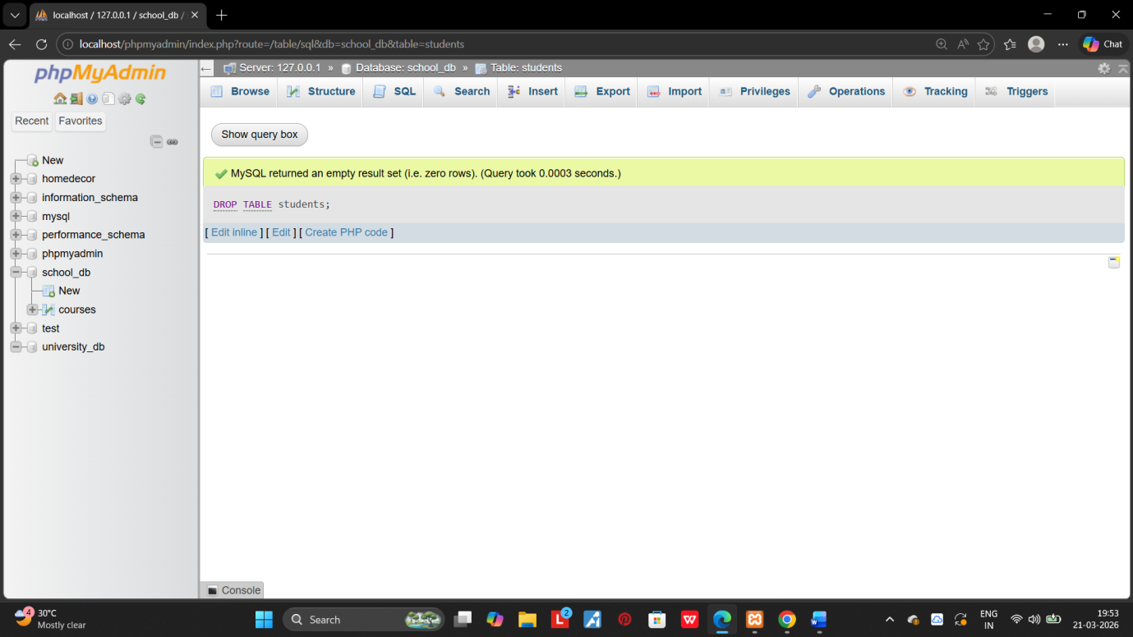

7.DATA MANIPLUTION LANGUAGE(DML):

1.Insert three record into the courses table using the INSERT command. 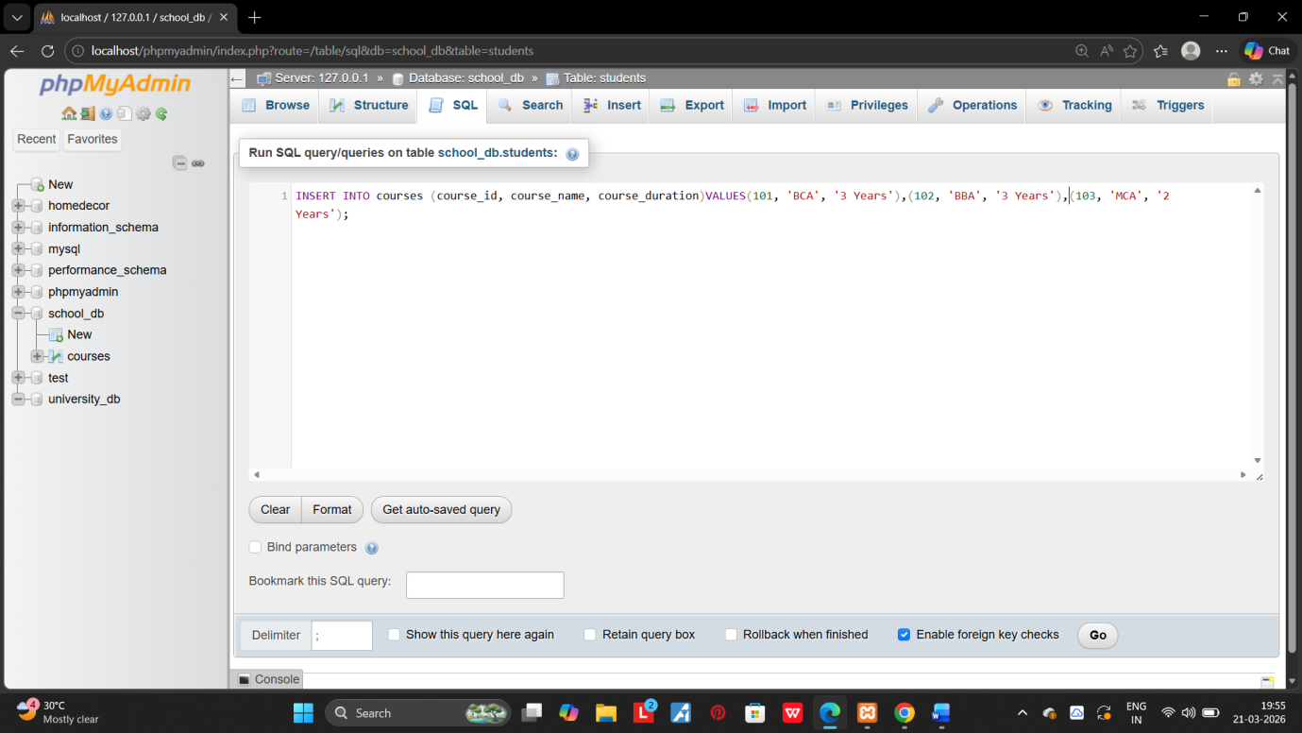
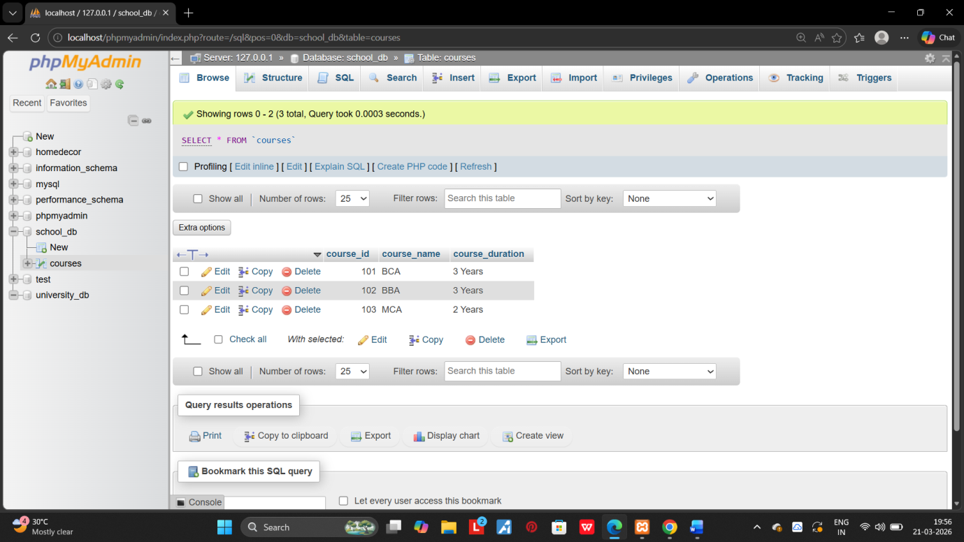

2.Update the course duration of specific course using the UPDATES commands. 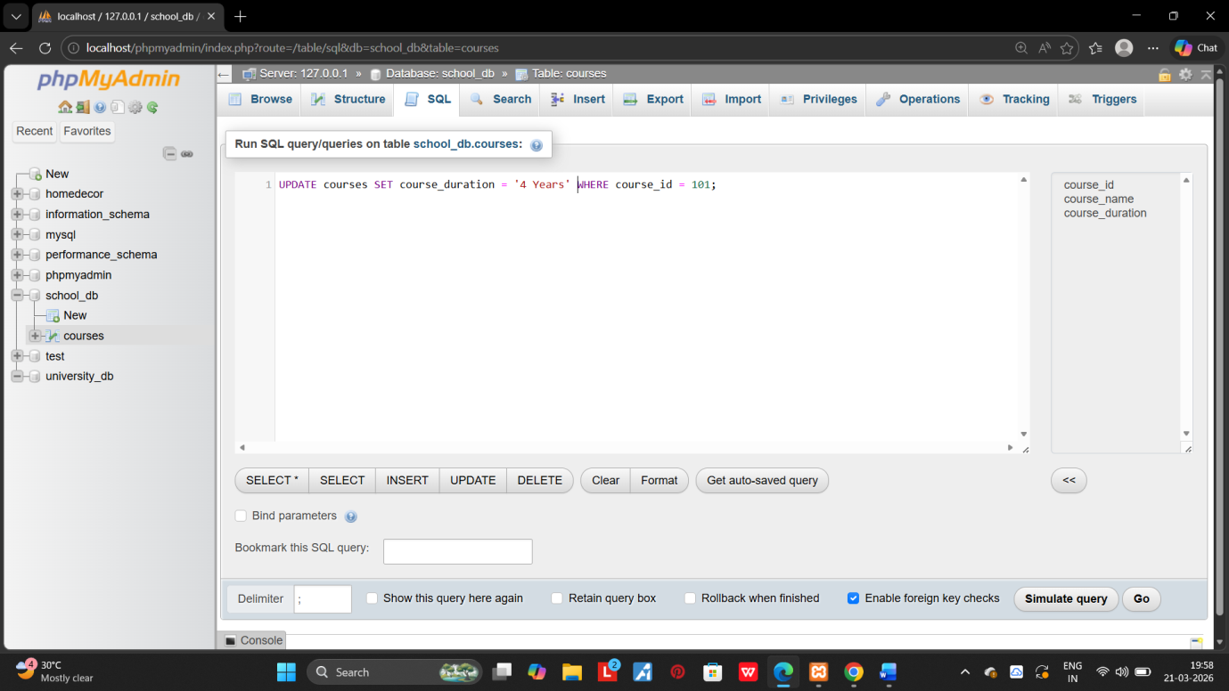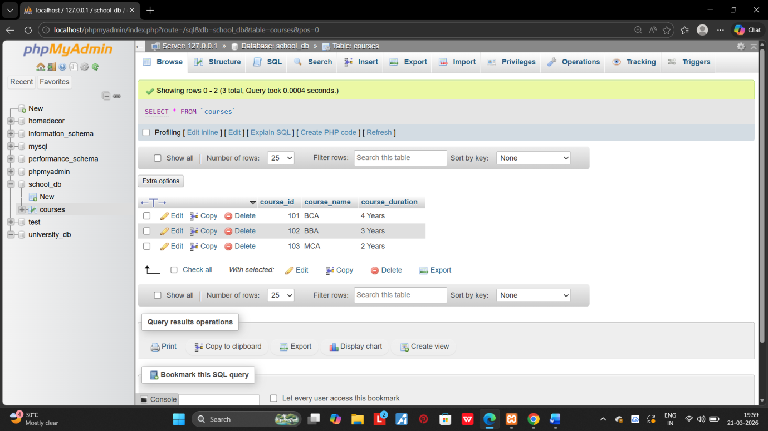
3.Delete a course with a specific course_id from the courses table using the DELETE command. 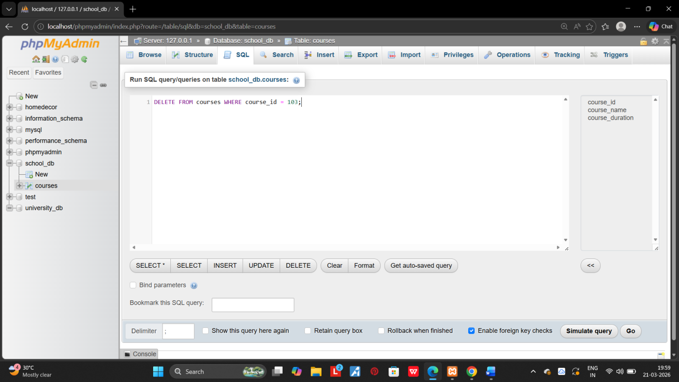
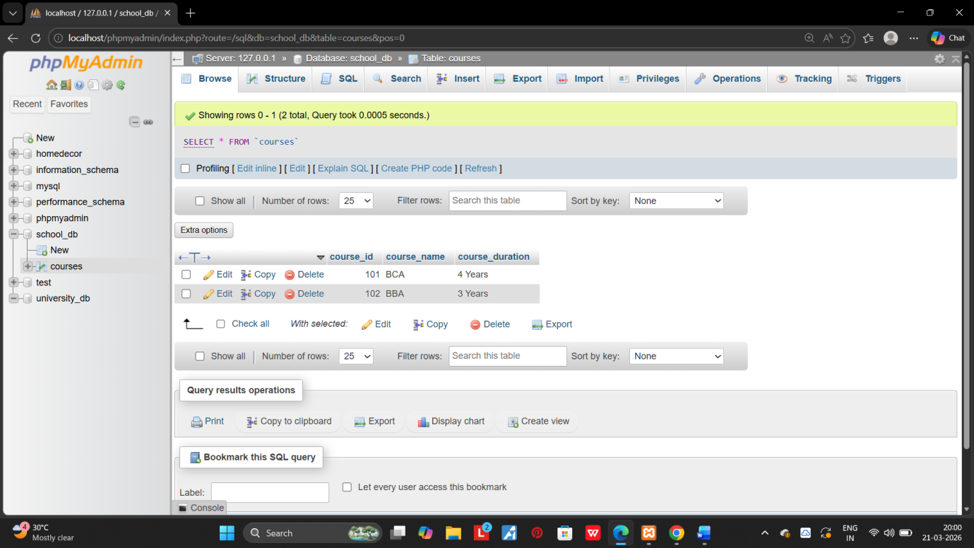

8.DATA QUERY LANGUAGE(DQL):

1.Retrive all courses from the courses table using the SELECTS statement.
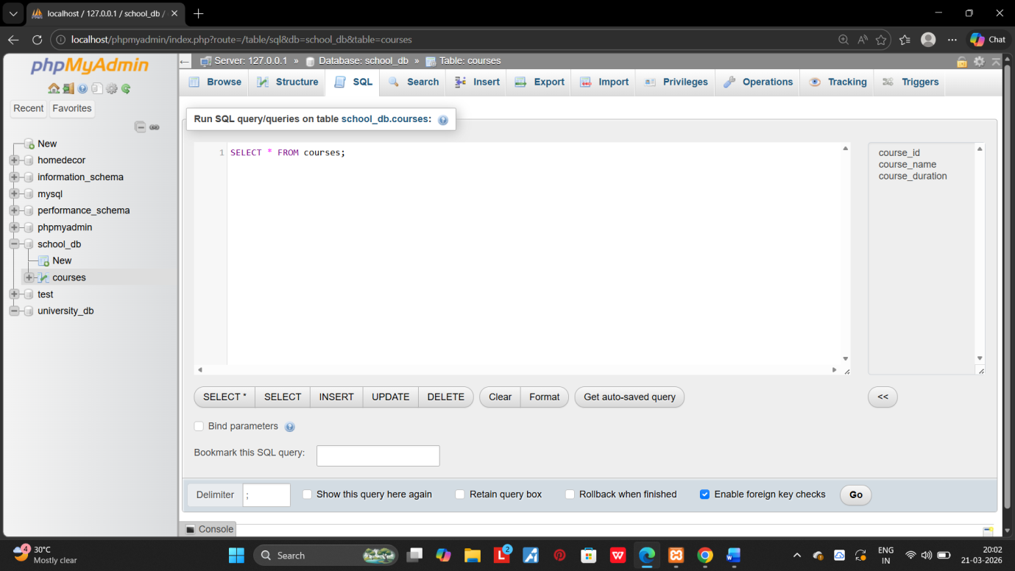

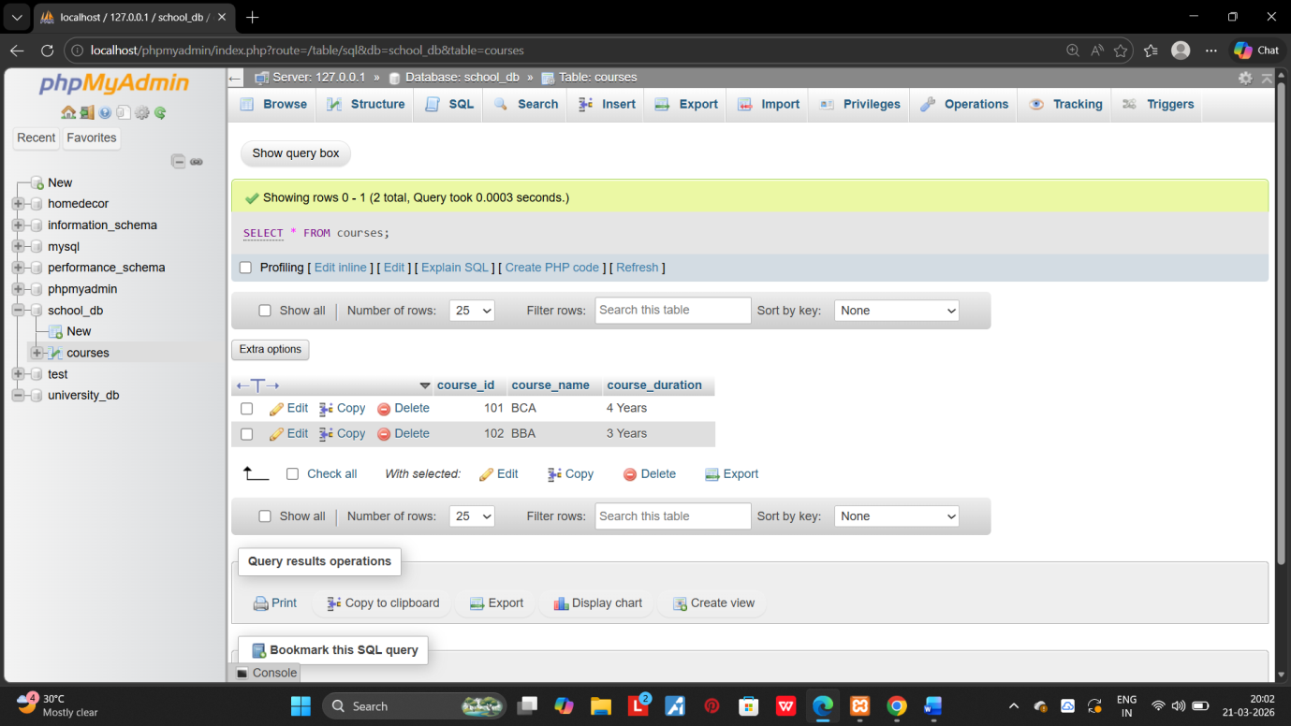
2.Sort the courses based on course_duration in descending order using ORDER by. 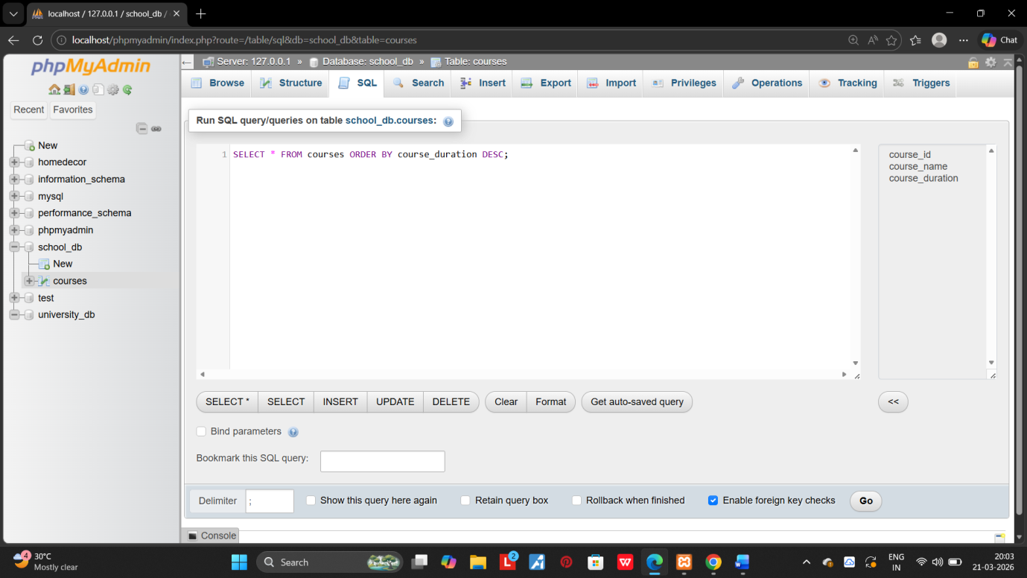

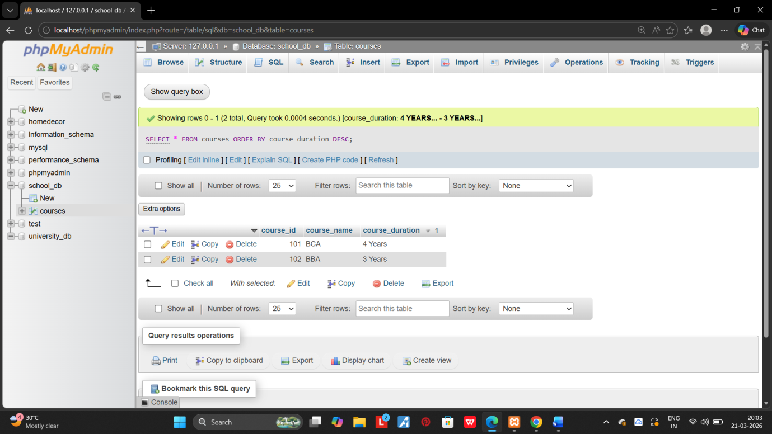

3.Limit the results of the SELECT query to show only the op two courses using LIMIT. 